Project Name: Wedding Photo
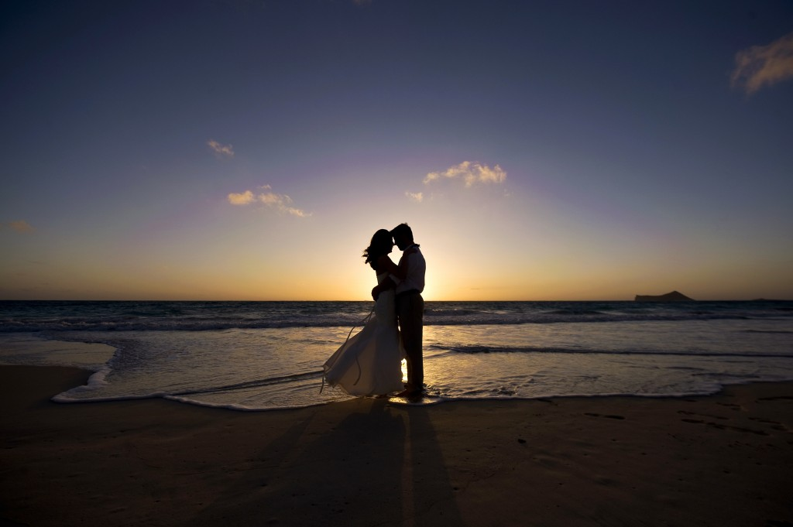
Original Image/s:
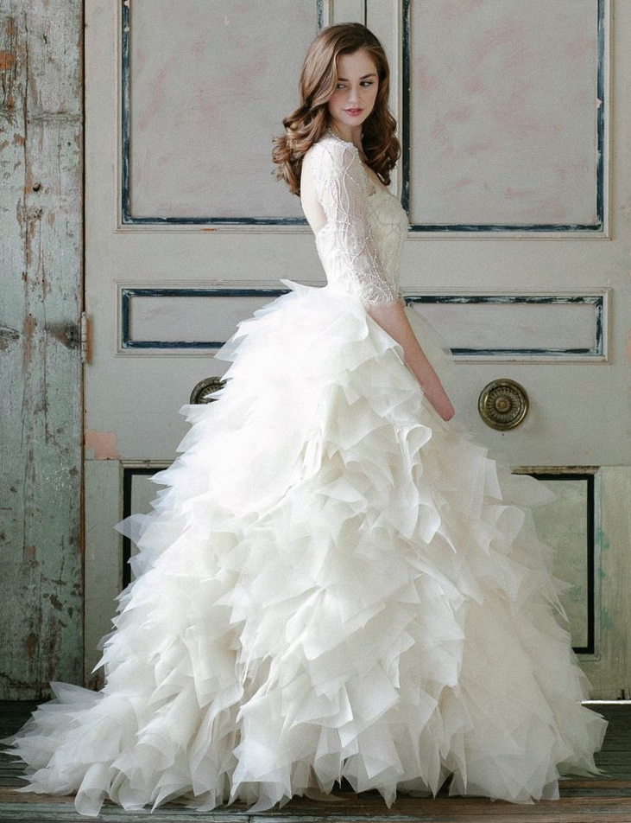

Detail the Steps taken to Enhance the Image:
1. Open the images in Photoshop.
2. Click on bride image select the Eraser Tool and go around her then select Quick Selection Tool and select her body.

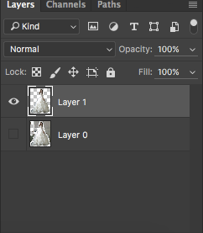
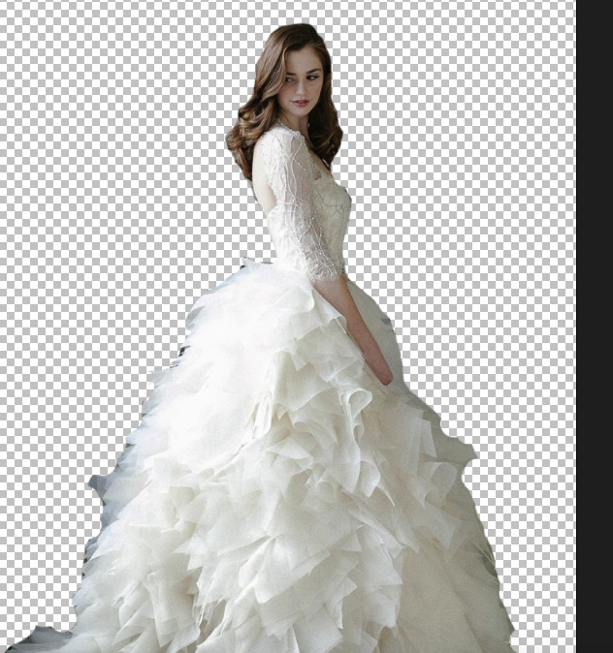
Cmd + J to make another layer for her with you select after delete the mother layer.
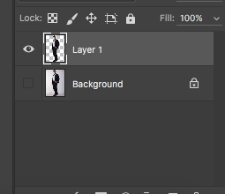
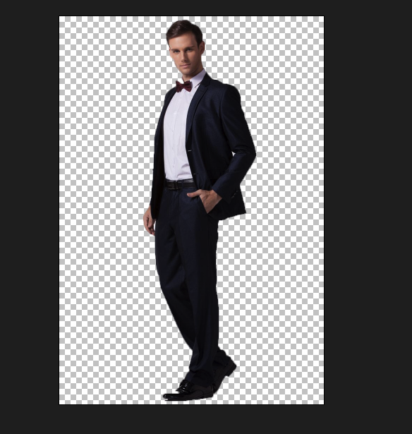
3. Select the groom image then do the same thing like the bride but I only used the Quick Selection Tool to select him and Cmd + J to make the new layer and delete the mother layer.

4. Cmd + A, Cmd + D each image to the first image. The bride at the left side and the groom at the right side. Use Cmd + T to make it bigger than the mother image until I feeling it.
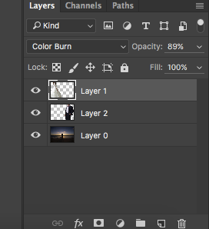
5. Go to the bride image and change Kind to Color Burn and fill the Opacity down 89%. Then do the same to the groom image but Opacity 51%.

6. Go to Channel and select Blue.
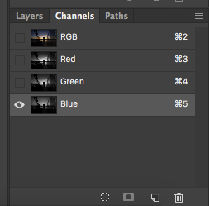
Final Image:
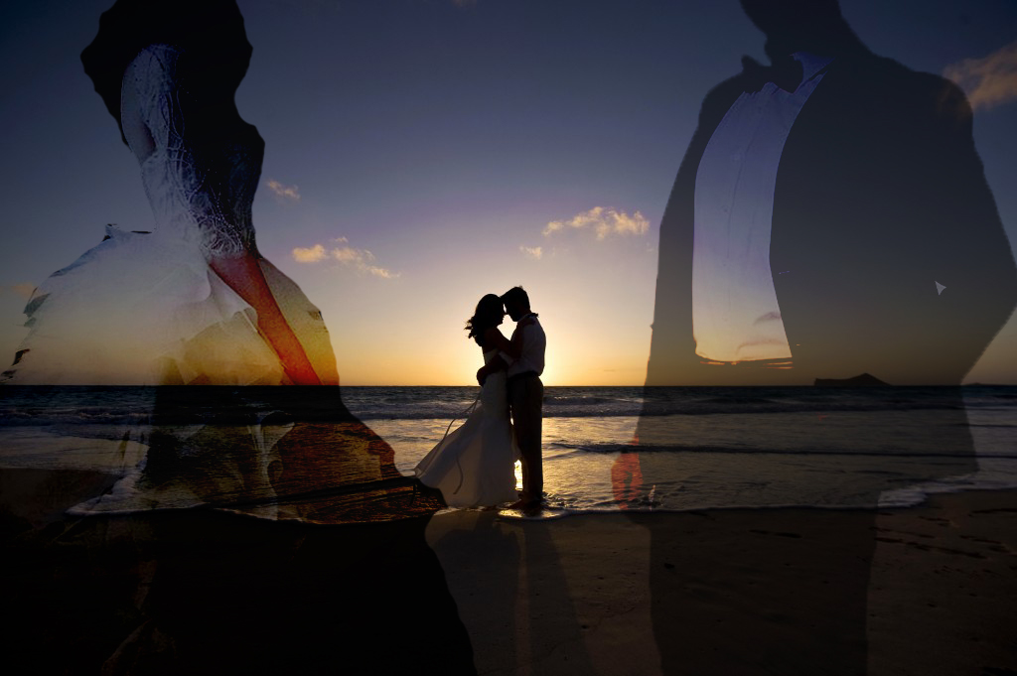
Save the file as a (1) .pdf and (2) a .jpg on your own hard drive/USB.

